
Department | FED
Subject | DSA-2
Academic Year | I-III Semester (2025-26)
Faculty Name | RAZIA BANU
Student Name | P SHASHE PREETHAM
Roll Number | 2520030534
Branch | CSE
Course Outcome | CO2

Case Study Topic: HDFC NetBanking Daily Spend Analysis using Fenwick Tree (Set 3 Q2)
Work Done Summary:
In this case study, we implemented a Fenwick Tree (Binary Indexed Tree) to analyze daily spending records efficiently. The structure was used to calculate prefix sums and range-sum queries without scanning the entire dataset. Daily transaction amounts were inserted into the BIT array, and spending between selected dates was computed. The calculated result was verified with manual computation. The implementation demonstrated how Fenwick Trees reduce query time to O(log n). This makes them suitable for banking and financial analytics applications..

Implementation Details:
- Constructed Binary Indexed Tree.
- Performed point updates.
- Calculated prefix sums.
- Executed range query from day 5 to day 12.
- Verified answer ₹7650.

Result: Screenshots / Output
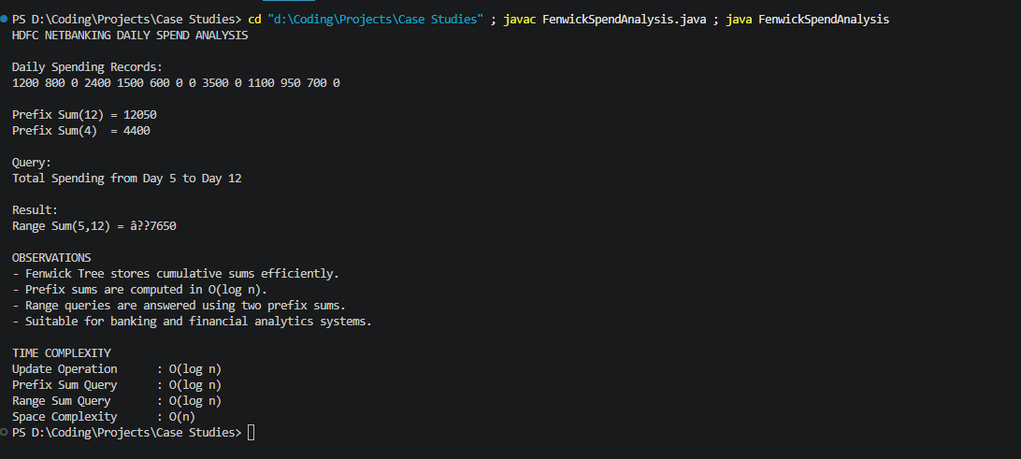
Prefix Sum(12) = 12050
Prefix Sum(4) = 4400
Range Sum(5,12) = ₹7650
Update Operation : O(log n)
Prefix Sum Query : O(log n)
Range Sum Query : O(log n)
Space Complexity : O(n)

GITHUB LINK : https://github.com/tanyasri1405/DSA---case-study-2.git

Student Signature | Faculty Signature

